2）FGSM

* MNIST

|  |  |
| --- | --- |
|  | L2 Distance:  58.638947 |
|  | 49.684406 |
|  | 53.834755 |
|  | 54.681152 |
|  | 52.770157 |
|  | 43.568077 |
|  | 56.02453 |
|  | 50.098133 |
|  | 53.93727 |
|  | 44.248154 |

* Fashion MNIST

|  |  |
| --- | --- |
|  | L2 Distance:  49.731827 |
|  | 52.33737 |
|  | 52.33743 |
|  | 57.61750 |
|  | 46.305008 |
|  | 49.135406 |
|  | 52.868507 |
|  | 58.084663 |
|  | 50.613808 |
|  | 58.124342 |

* Cifar10

|  |  |
| --- | --- |
|  | L2 Distance:  58.34123 |
|  | 60.342 |
|  | 70.34234 |
|  | 40.34237 |
|  | 70.59182 |
|  | 60.23486 |
|  | 65.45893 |
|  | 58.65934 |
|  | 50.83458 |
|  | 58.485 |

Basic Iterative Method

* MNIST

|  |  |
| --- | --- |
|  | L2 Distance:  68.2348 |
|  | 69.3845 |
|  | 65.2384 |
|  | 20.459 |
|  | 54.148 |
|  | 44.349 |
|  | 34.549 |
|  | 49.4859 |
|  | 45.48235 |
|  | 33.12348 |

* Fashion MNIST

|  |  |
| --- | --- |
|  | L2 Distance:  36.150993 |
|  | 35.113922 |
|  | 32.874474 |
|  |  |
|  | 38.022118 |
|  | 29.258118 |
|  | 40.22332 |
|  | 32.052715 |
|  | 32.017265 |
|  | 33.219147 |

* Cifar10

|  |  |
| --- | --- |
|  | L2 Distance:  67.3489 |
|  | 65.34823 |
|  | 79.3458 |
|  | 68.34588 |
|  | 78.3458 |
|  | 68.3412 |
|  | 54.2913 |
|  | 32.495 |
|  | 50.1923 |
|  | 60.4903 |

Momentum Iterative method

* MNIST

|  |  |
| --- | --- |
|  | L2 Distance:  58.638947 |
|  | 49.684406 |
|  | 53.834755 |
|  | 54.681152 |
|  | 52.770157 |
|  | 43.568077 |
|  | 56.02453 |
|  | 50.098133 |
|  | 53.93727 |
|  | 44.248154 |

* Fashion MNIST

|  |  |
| --- | --- |
|  | 41.135635 |
|  | 45.73863 |
|  | 38.48382 |
|  | 41.70452 |
|  | 32.59449 |
|  | 47.682644 |
|  | 38.61961 |
|  | 34.96115 |
|  | 44.893368 |
|  | 46.37036 |

* Cifar10

|  |  |
| --- | --- |
|  | 45.4934 |
|  | 74.4539 |
|  | 34.5965 |
|  | 56.23459 |
|  | 65.3459 |
|  | 70.3495 |
|  | 69.495 |
|  | 55.546 |
|  | 34.2341 |
|  | 54.895 |

SMA

* MNIST

|  |  |
| --- | --- |
|  | L2 Distance:  58.996033 |
|  | 14 |
|  | 13.958878 |
|  | 28.186512 |
|  | 22.35225 |
|  | 40.974213 |
|  | 19.889889 |
|  | 17.790482 |
|  | 68.6289 |
|  | 10.442184 |

* Cifar10

|  |  |
| --- | --- |
|  | L2 Distance:  3.293041 |
|  | 16.619839 |
|  | 4.5920796 |
|  | 6.6491357 |
|  | 20.610796 |
|  | 3.504764 |
|  | 10.67778 |
|  | 49.69607 |
|  | 2.267498 |
|  | 2.710019 |

3)

|  |  |  |  |
| --- | --- | --- | --- |
| MNIST | FGSM | Test accuracy on legitimate examples: 0.9934  Test accuracy on adversarial examples: 0.1143  After:  Test accuracy on legitimate examples: 0.7957  Test accuracy on adversarial examples: 0.2254 |  |
|  | BIM | Test accuracy on legitimate examples: 0.9932  Test accuracy on adversarial examples: 0.0059  After:  Test accuracy on legitimate examples: 0.7858  Test accuracy on adversarial examples: 0.1493 |  |
|  | MIM | Test accuracy on legitimate examples: 0.9937  Test accuracy on adversarial examples: 0.0049  After:  Test accuracy on legitimate examples: 0.8150  Test accuracy on adversarial examples: 0.1175 |  |

|  |  |  |  |
| --- | --- | --- | --- |
| FMNIST | FGSM | Test accuracy on legitimate examples: 0.9049  Test accuracy on adversarial examples: 0.0631  After:  Test accuracy on legitimate examples: 0.7112  Test accuracy on adversarial examples: 0.1498 |  |
|  | BIM | Test accuracy on legitimate examples: 0.9058  Test accuracy on adversarial examples: 0.0636  After:  Test accuracy on legitimate examples: 0.7121  Test accuracy on adversarial examples: 0.0974 |  |
|  | MIM | Test accuracy on legitimate examples: 0.9050  Test accuracy on adversarial examples: 0.0643  After:  Test accuracy on legitimate examples: 0.7153  Test accuracy on adversarial examples: 0.1179 |  |

|  |  |  |  |
| --- | --- | --- | --- |
| CIFAR10 | FGSM | Test accuracy on legitimate examples: 0.7838  Test accuracy on adversarial examples: 0.1295  After:  Test accuracy on legitimate examples: 0.7657  Test accuracy on adversarial examples: 0.6540 |  |
|  | BIM | Test accuracy on legitimate examples: 0.7891  Test accuracy on adversarial examples: 0.0734  After:  Test accuracy on legitimate examples: 0.7793  Test accuracy on adversarial examples: 0.0994 |  |

4)

White Box Attack:

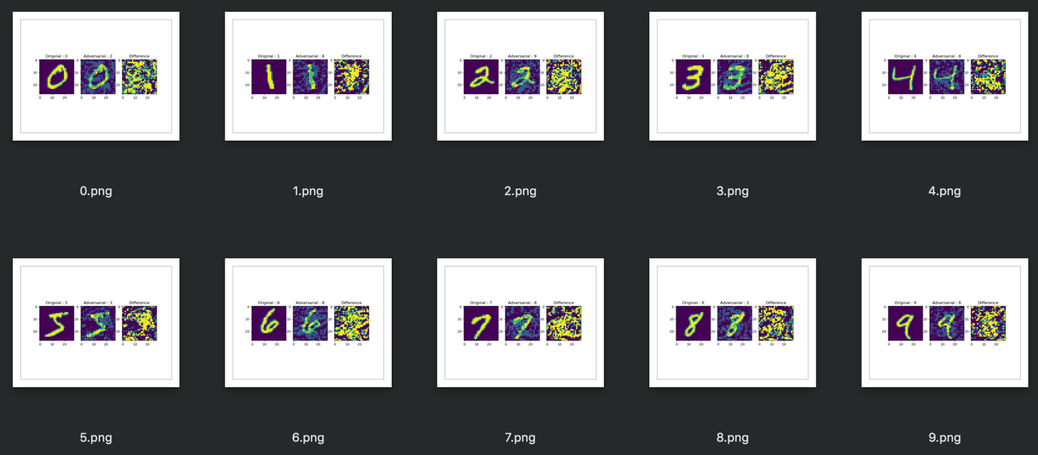

Black Box Attack:



Black box trains a local model to substitute for the target DNN, using the inputs synthetically generated by an adversary and labeled by the target DNN. As black box suggested, it has no information about the structure or parameters of the DNN, and also does not have access to any large training dataset. It can only observe labels assigned by the DNN for chosen inputs. It segregates and train a local substitute with a synthetic dataset – the inputs are synthetic and generated by the adversary while the outputs are labels assigned by the target DNN and observed by the adversary. Black box strategy is to learn the substitute for the target model using a synthetic dataset generated by the adversary and labeled by observing the oracle output. Then, the adversarial examples are crafted using this substitute. We can see that the target DNN misclassified them due to the transferability between architecture.

For the white box attack, the intruder has the access to the model’s parameters while the black box attacks the intruder has zero access to these parameters. It uses different model to generate adversarial images and run against the target model.

The results show that the white box attack using the basic iterative method achieves better results on the adversary, and also outperforms the ones with black box attack. The performance in black box attacks declined along with the number of epochs in the basic iterative method.

As shown in the figure above, the labeling between the input and the adversary does not make a significant result in the black box attack. Whereas, in the white box attack, it has introduced adversarial noises which managed to fool the classifier to make the model misclassified label.